GIT Commands

Used the following commands:

1. git –version
2. git config –global user.name “Name”
3. git config –global user.email “email address”
4. git –help
5. 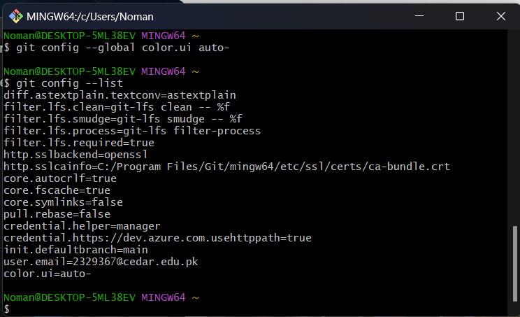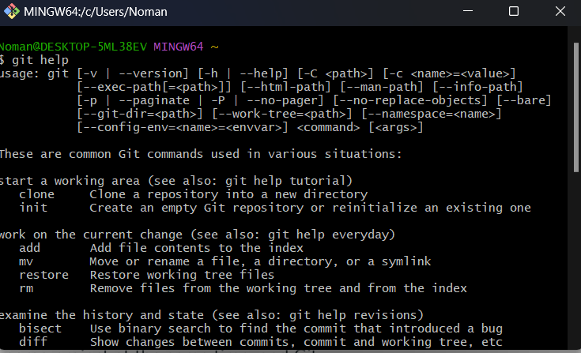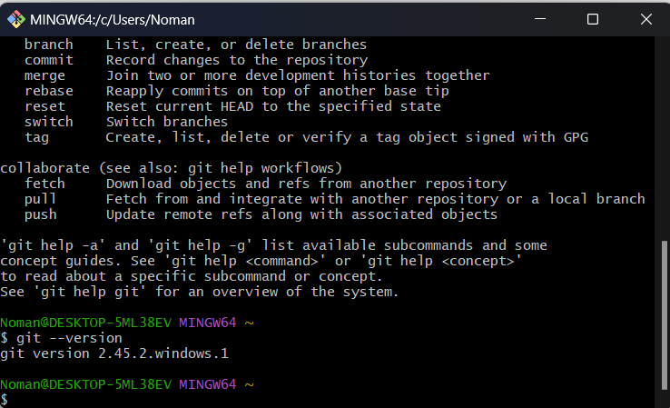git config --list